Unit 5: Decimals & Decimal Fractions

Homework Helper

MGSE4.NF.5 Express a fraction with denominator 10 as an equivalent fraction with denominator 100, and use this technique to add two fractions with respective denominators 10 and 100. For example, express 3/10 as 30/100, and add 3/10 + 4/100 = 34/100.

Decimal Fractions:

A fraction where the denominator (the bottom number) is a power of ten (such as 10, 100, 1000, etc).

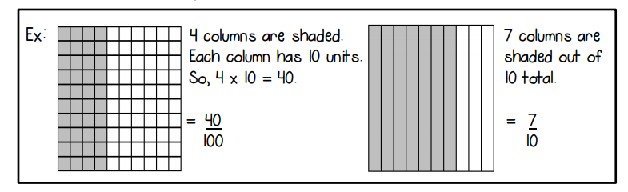

Equivalent Decimal Fractions

Create equivalent fractions using tenths and hundredths.

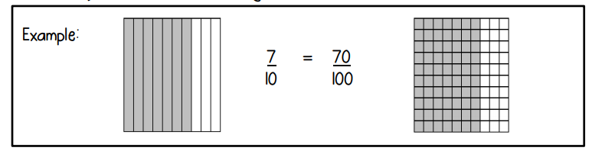

Add Fraction Parts: Tenths & Hundredths

When adding fractions with the denominators 10 and 100, you must create an equivalent fraction so that both have the denominator 100.

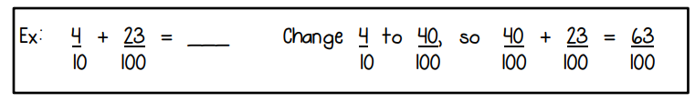

Add Fraction Parts: Tenths & Hundredths

You can also use models to show how to add fractional parts of 10 and 100. Use a different color to shade in each fraction.

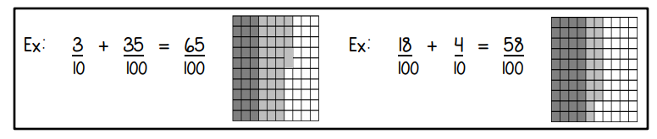

Add Fraction Parts: Write the Expression

Using the models provided, write an expression.

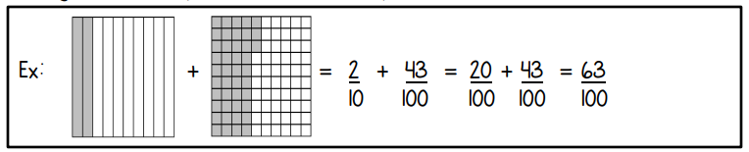

MGSE4.NF.6 Use decimal notation for fractions with denominators 10 or 100. For example, rewrite 0.62 as 62/100; describe a length as 0.62 meters; locate 0.62 on a number line diagram.

Relate Fractions and Decimals

Fractions and decimals both represent parts of a whole.

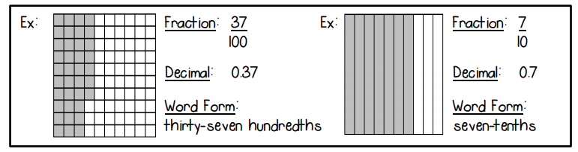

Convert Fractions to Decimals

Fractions and decimals can both represent the same parts of a whole.

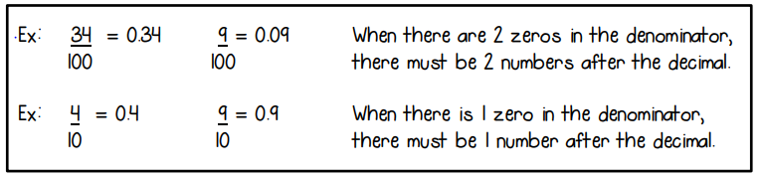

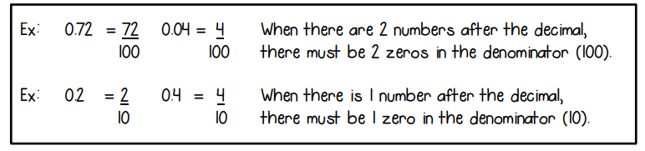

Decimals, Fractions, and Word Form

Fractions and decimals can both be written in word form.

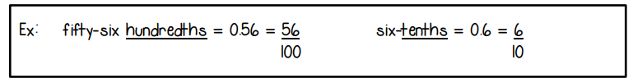

MGSE4.NF.7 Compare two decimals to hundredths by reasoning about their size. Recognize that comparisons are valid only when the two decimals refer to the same whole. Record the results of comparisons with the symbols >, =, or <, and justify the conclusions, e.g., by using a visual model.

Fractions and Decimals on a Number Line

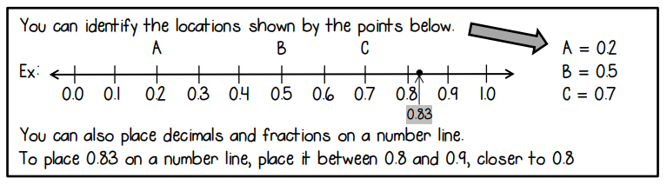

Compare Decimals Using Grids

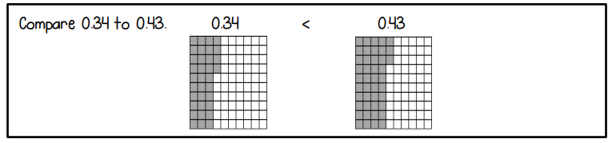

Compare Decimals Using Number Lines

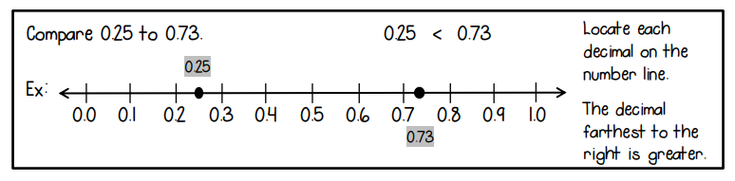

Compare Decimals

To compare decimals, compare place values. If needed, make an equivalent decimal so that both decimals have the same place values.

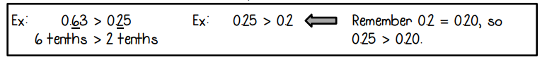

Order Decimals

To order decimals, compare place values. If needed, make an equivalent decimal so that all decimals have the same place values.

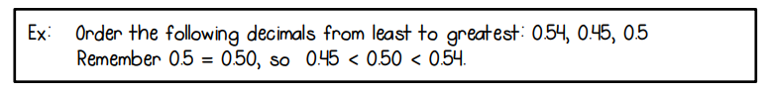

The website below has a good description, along with examples, of decimal numbers.

<http://www.mathsisfun.com/decimals.html>